SET OPERATORS – UNION, UNION ALL, INTERSECT, MINUS.

SYNONYMS : ITS LIKE NICK NAMES FOR A PERSON

PERMINANT ALIAS NAMES.

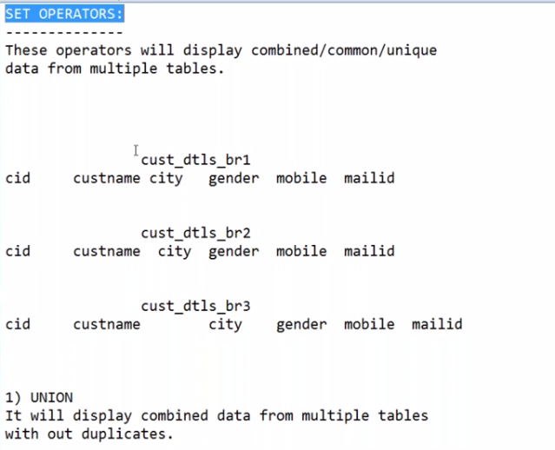

WE CAN COMBINE SIMILAR TYPE OF DATA

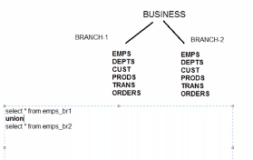

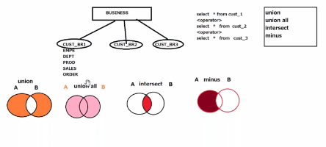

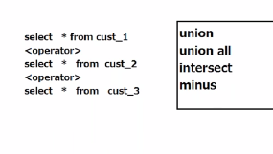

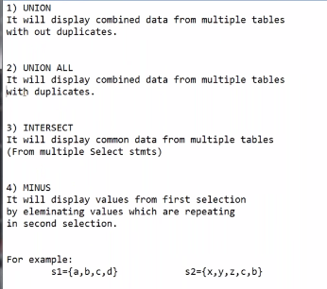

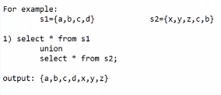

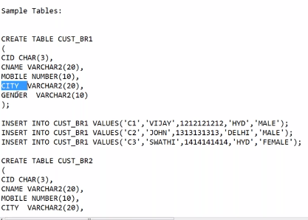

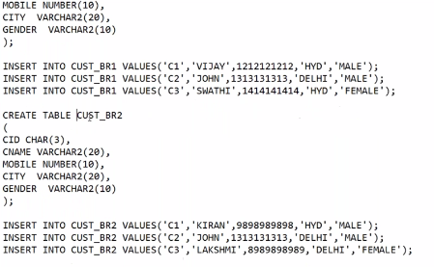

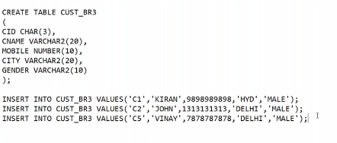

COMMIT;

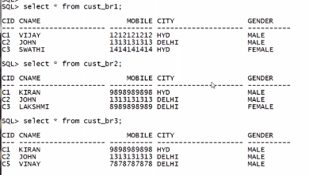

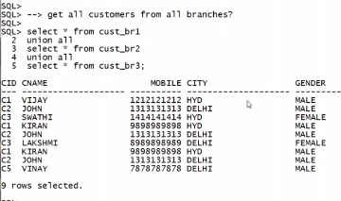

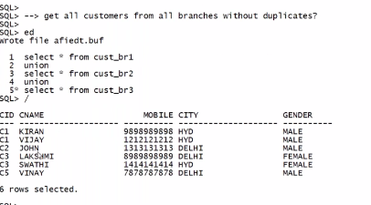

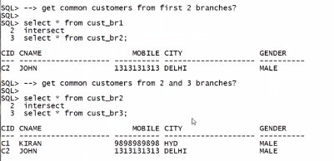

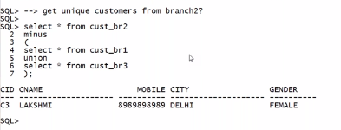

EACH SELECT QUERY SHOULD SELECT EQUAL NUMBER OF COLUMNS

SELECTED COLUMNS DATATYPES SHOULD BE SIMILAR IN THE SAME SEQUENCE.

ABOVE 2 LIMITATIONS CAN BE PROVED IN THE BELOW EXAMPLES.

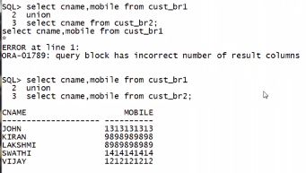

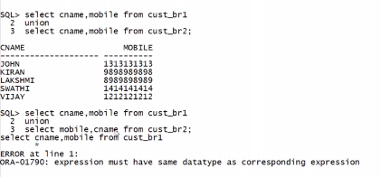

DON’T COMBINE DIFFERENT OBJECTS INFORMATION BY USING SET OPERATORS.



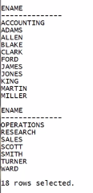

BUT SOME VALUES ARE ENAMES AND SOME VALUES ARE DEPT NAMES.

SO WE SHOULD NOT COMBINE DIFF OBJECTS INFORMATION EVEN THEY BELONG TO SAME DATA TYPE.

TO CREATE SYNONYM WE SHOULD HAVE PERMISSION FROM DBA, OTHERWISE WE CANT CREATE.

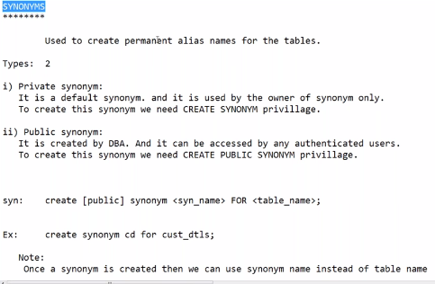

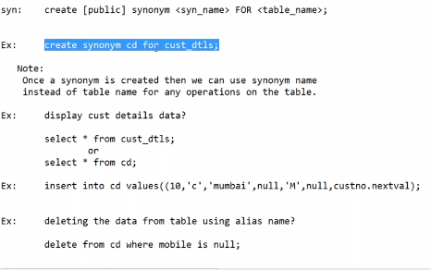

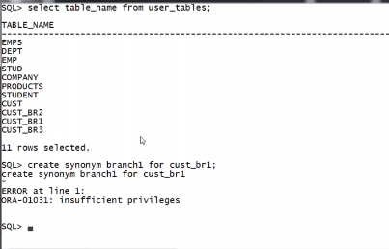

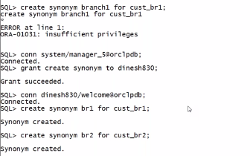

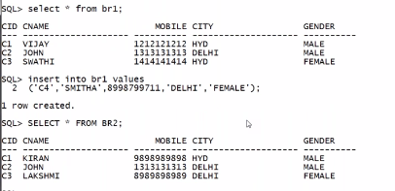

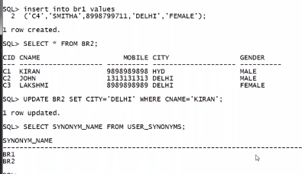

HERE IF WE DELETE THE TABLE EVEN THEN THE SYNONYM WILL NOT BE DELETED.

BUT IT BECOME INVALID OBJECT AUTOMATICALLY

.